SIMATS ENGINEERING
ASSESSMENT TOOL 2

COURSE NAME: Database Management Systems
COURSE CODE: CSA05
NAME: J Jaslin
REG NO: 192321175

COURSE OUTCOME COVERED

CO1: Analyze DBMS architecture, different data models, schema types, and design ER/EER diagrams, relational schemas for case-based scenarios by identifying entities and relationships. (BL1, BL2)

Activity Tool : Concept Mapping (Medium)
Assessment Tool Weightage: 35%

Dr Jaya Mabel Rani
QUESTIONS Total Marks: 50
Q.No | Question | Bloom's Level | Marks
1 | Construct a concept map linking the following terms: DBMS, Schema, Instance, Data Model, ER Diagram, Entity, Attribute, Relationship. | BL2 – Understand | 5
2 | Create a concept map for the three-level ANSI/SPARC architecture showing data independence at each level. | BL2 – Understand | 5
3 | Map the relationship between file-based systems and database systems, highlighting the problems solved by DBMS. | BL2 – Understand | 5
4 | Design a concept map for ER diagram components: entity, weak entity, attribute types, relationship types, and participation constraints. | BL2 – Understand | 5
5 | Construct a concept map comparing Hierarchical, Network, and Relational data models with their key properties. | BL2 – Understand | 5
6 | Develop a concept map for the EER model showing how it extends the basic ER model with generalization, specialization, and aggregation. | BL2 – Understand | 5
7 | Create a visual concept map for the DBMS software architecture, illustrating the flow from user request to data retrieval. | BL2 – Understand | 5
8 | Map the data models discussed in CO1 to real-world applications and explain the suitability of each model. | BL2 – Understand | 5
9 | Construct a concept map for schemas and instances, showing how they relate to physical and logical data independence. | BL2 – Understand | 5
10 | Design a concept map for the roles and responsibilities in a DBMS environment: DBA, End User, Application Developer. | BL1 – Remember | 5

Code of Conduct:

I, _J Jaslin / 192321175_ (Name / Reg No) certify that this submission is my original work and that I have adhered to the guidelines specified for this assessment.
I understand that any violation of academic integrity rules will result in disciplinary action.

Signature of the student:
jaslin

RUBRICS FOR CALCULATION:

Criteria | Weightage | Level 4 (Exemplary) | Level 3 (Proficient) | Level 2 (Developing) | Level 1 (Beginning)
Concept Identification | 25% | Identifies all key concepts from literature accurately and comprehensively | Identifies most key concepts with minor omissions | Identifies limited concepts; some are irrelevant or missing | Fails to identify essential concepts
Linkages | 25% | Establishes clear, meaningful, and accurate relationships between concepts | Shows correct relationships with minor gaps | Relationships are weak, unclear, or partially incorrect | No meaningful relationships established
Organization | 20% | Concepts are well-structured hierarchically with logical flow and grouping | Mostly organized with minor structural issues | Some organization but lacks clear hierarchy | No logical organization or structure
Integration of Literature | 20% | Integrates multiple studies effectively to show connections and comparisons | Shows some integration of literature | Limited integration; mostly isolated concepts | No integration of literature evidence
Clarity | 10% | Concept map is clear, neat, visually structured, and easy to interpret | Generally clear with minor readability issues | Clarity is reduced; difficult to interpret in parts | Poorly presented and hard to understand
Answer 1: Concept Map — DBMS, Schema, Instance, Data Model, ER Diagram, Entity, Attribute, Relationship
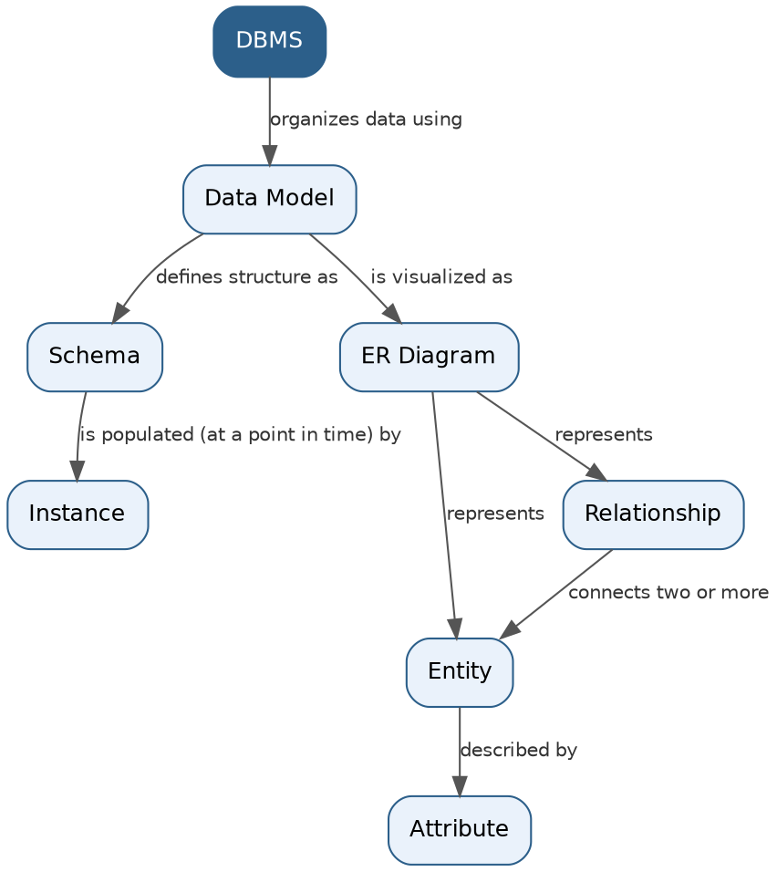
• DBMS (Database Management System) is the software that organizes and manages data using a chosen Data Model.
• A Data Model provides the rules and concepts used to describe the structure of the database; this structure is called the Schema.
• The Schema is the logical design of the database and remains relatively stable, while the Instance is the actual data stored in the database at a given moment in time — the Instance changes every time data is inserted, updated, or deleted.
• The Data Model (in particular the ER Model) is visually expressed through an ER Diagram.
• An ER Diagram represents real-world objects as Entities (e.g., Student, Course).
• Each Entity is described by Attributes (e.g., a Student entity has Name, Roll No, Date of Birth).
• Entities are linked to one another through Relationships (e.g., Student 'enrolls in' Course), which capture how entities interact.
Answer 2: Concept Map — Three-Level ANSI/SPARC Architecture
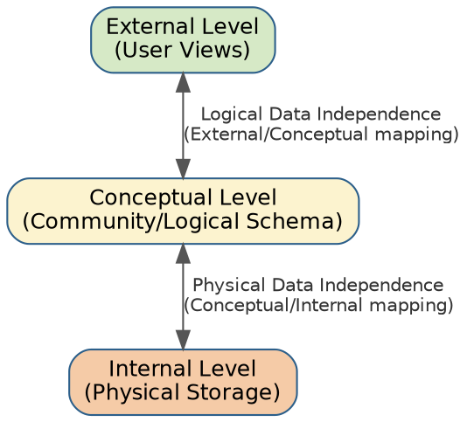
• External Level: closest to the users; consists of multiple user views, each showing only the part of the database relevant to a particular user or application.
• Conceptual Level: the community/logical view; describes the structure of the whole database for the community of users, hiding physical storage details.
• Internal Level: closest to physical storage; describes how data is actually stored — file organization, indexes, and access paths.
• Logical Data Independence is the capacity to change the Conceptual schema without having to change External schemas or application programs.
• Physical Data Independence is the capacity to change the Internal schema (e.g., storage structures) without having to change the Conceptual schema.
• Together, these mappings insulate each level from changes in the level below it, which is the central goal of the three-level architecture.
Answer 3: Concept Map — File-Based Systems vs Database Systems
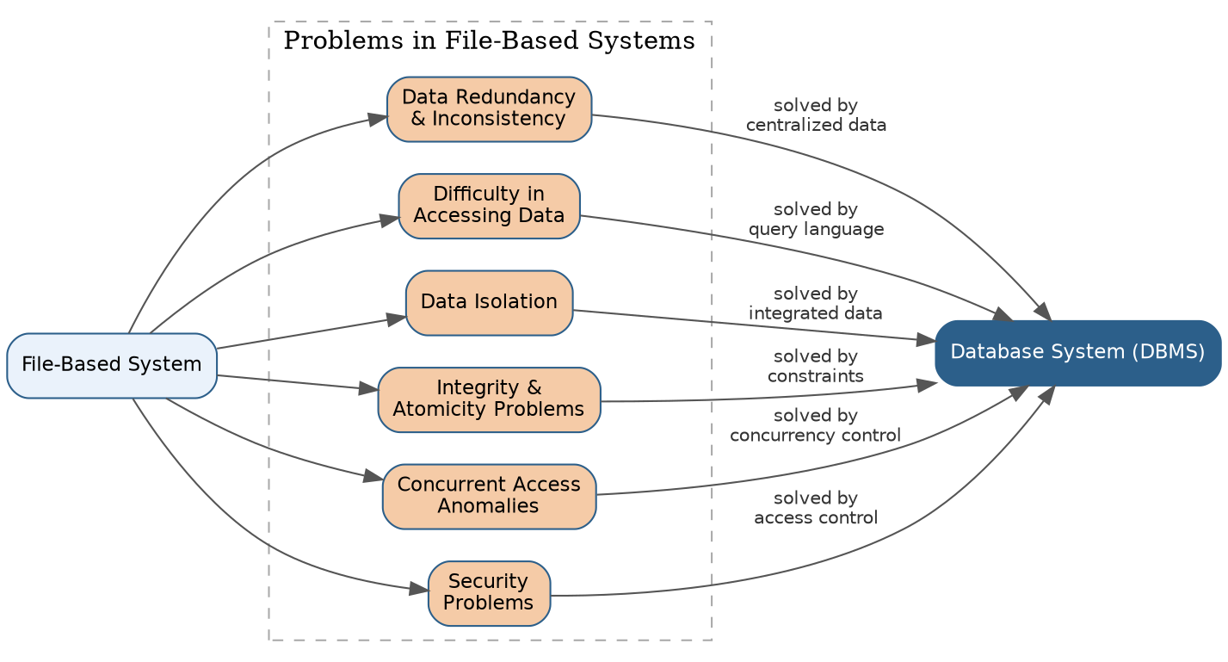

• File-Based Systems store data in independent files maintained separately by each application program, which leads to several well-known problems.
• Data Redundancy & Inconsistency: the same data is duplicated across multiple files, so updating one copy without updating the others causes inconsistency.
• Difficulty in Accessing Data: retrieving data often requires writing a new program for every new query since there is no generalized query facility.
• Data Isolation: data is scattered in various files with different formats, making it hard to write programs that combine data from multiple sources.
• Integrity & Atomicity Problems: constraints (e.g., balance must not be negative) are buried in application code rather than enforced centrally, and a failure mid-update can leave data in an inconsistent state.
• Concurrent Access Anomalies: uncontrolled simultaneous access by multiple users/programs can corrupt data.
• Security Problems: it is difficult to enforce access restrictions when every application implements its own security independently.
• A DBMS solves all these problems through centralized data storage, a data dictionary, a query language, concurrency control, and integrity/security enforcement built into the system itself.
Answer 4: Concept Map — ER Diagram Components
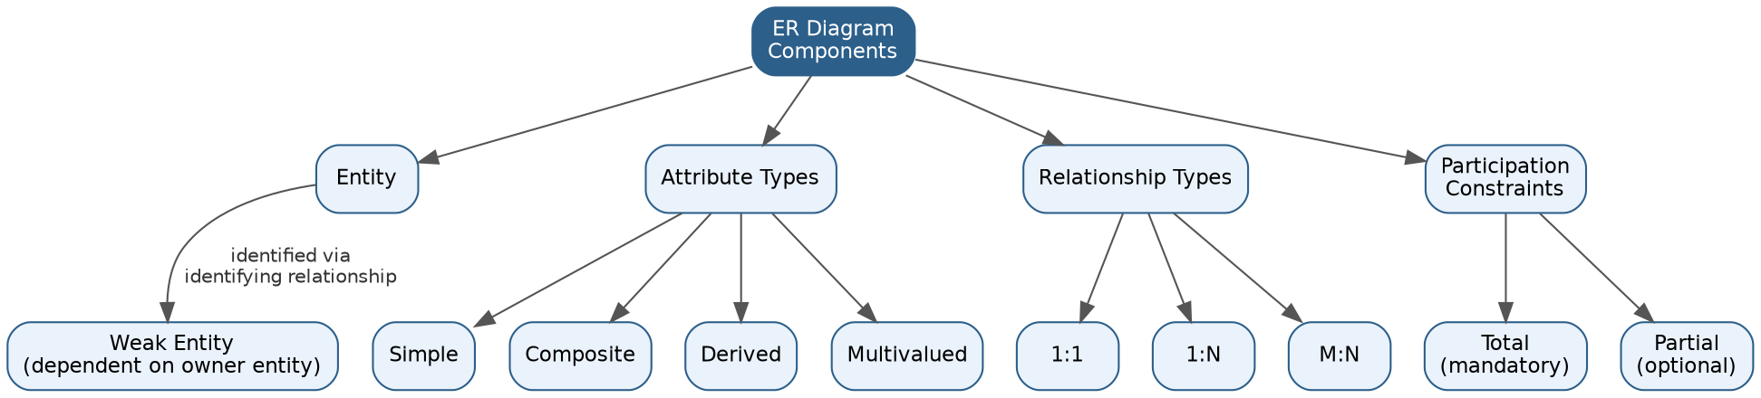

• Entity: a real-world object or concept (e.g., Employee) that has independent existence and can be uniquely identified.
• Weak Entity: an entity that cannot be uniquely identified by its own attributes alone; it depends on a related 'owner' entity through an identifying relationship (e.g., Dependent depends on Employee).
• Attribute Types: Simple (atomic, e.g., Age), Composite (can be divided further, e.g., Name → First Name + Last Name), Derived (computed from other attributes, e.g., Age derived from Date of Birth), and Multivalued (can hold more than one value, e.g., Phone Numbers).
• Relationship Types: classified by cardinality ratio — 1:1 (one-to-one), 1:N (one-to-many), and M:N (many-to-many) — describing how many instances of one entity relate to instances of another.
• Participation Constraints: Total participation means every instance of an entity must participate in the relationship (shown with a double line), while Partial participation means participation is optional (shown with a single line).
Answer 5: Concept Map — Hierarchical, Network, and Relational Data Models
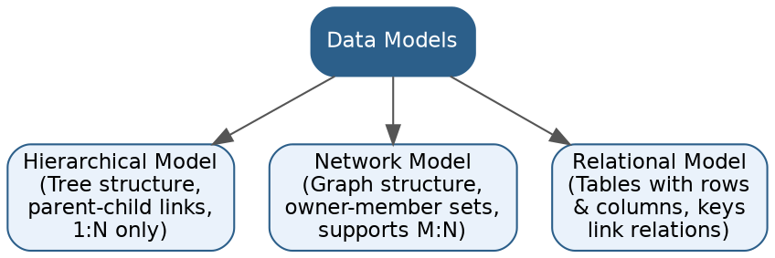

• Hierarchical Model: organizes data as a tree, with each child record having exactly one parent; relationships are strictly 1:N, which makes many-to-many associations awkward to represent.
• Network Model: organizes data as a graph using owner-member sets, allowing a record to have multiple parents; this makes it capable of representing M:N relationships more naturally than the hierarchical model.
• Relational Model: organizes data as a collection of tables (relations) made up of rows and columns; relationships between tables are expressed through common attributes (keys) rather than physical pointers.
• Key comparison: Hierarchical and Network models are navigational (data accessed by following predefined paths/pointers) and rigid to restructure, whereas the Relational model is declarative (accessed via query languages like SQL), flexible, and provides strong data independence.
Answer 6: Concept Map — EER Model Extensions
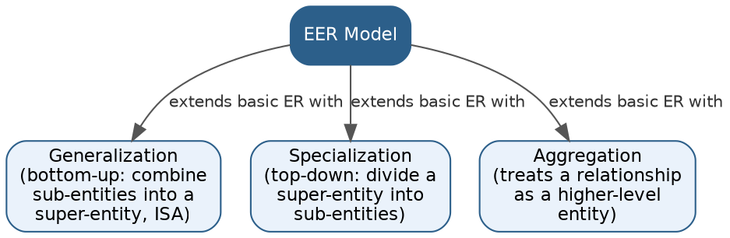

• The Enhanced ER (EER) Model extends the basic ER Model with additional semantic concepts needed to model complex applications.
• Generalization: a bottom-up process where several lower-level entity types with common features are combined into one higher-level (super class) entity type — this is the 'IS-A' relationship (e.g., Car and Truck generalized into Vehicle).
• Specialization: a top-down process where a higher-level entity type is divided into two or more lower-level (sub class) entity types based on distinguishing characteristics (e.g., Employee specialized into Manager and Engineer).
• Aggregation: a concept that allows a relationship between entities to be treated as a higher-level entity in its own right, so that it can itself participate in further relationships (e.g., the relationship 'Works_On' between Employee and Project can be aggregated to relate to a Manager entity).
Answer 7: Concept Map — DBMS Software Architecture (User Request to Data Retrieval)
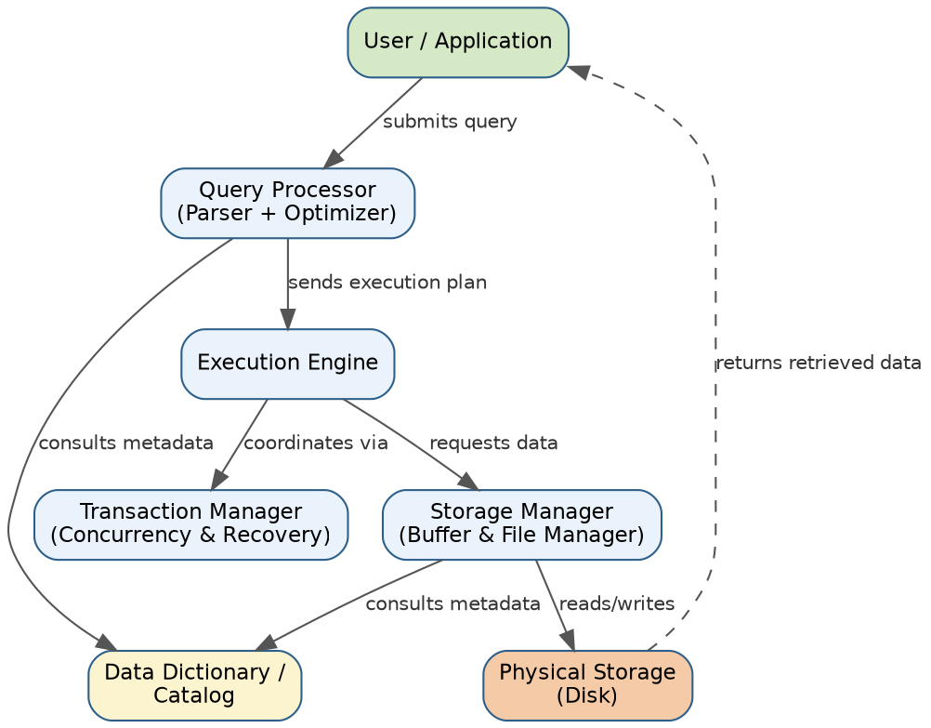

• The User/Application submits a query or transaction request to the DBMS.
• The Query Processor (Parser and Optimizer) checks the query's syntax, validates it against the Data Dictionary/Catalog, and generates an efficient execution plan.
• The Execution Engine carries out the plan, coordinating with the Transaction Manager to ensure concurrency control and recovery (ACID properties) during the operation.
• The Storage Manager (Buffer Manager and File Manager) translates the execution engine's requests into low-level read/write operations on Physical Storage (disk).
• Retrieved data flows back up through the storage manager and execution engine to be returned to the user, completing the request-to-retrieval cycle.
Answer 8: Concept Map — Data Models Mapped to Real-World Applications
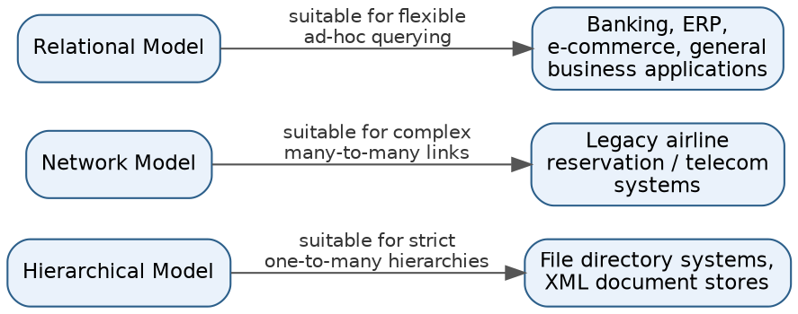

• Hierarchical Model → suited to strictly one-to-many hierarchies, such as file directory systems and XML document stores, where each element naturally has a single parent.
• Network Model → suited to applications with complex many-to-many relationships that need multiple ownership paths, historically used in legacy airline reservation and telecommunication systems.
• Relational Model → suited to general-purpose, flexible, and ad-hoc querying needs, making it the standard choice for banking systems, ERP software, and e-commerce platforms.
• The suitability of each model depends on how naturally its structure (tree, graph, or table) matches the relationships present in the real-world application.
Answer 9: Concept Map — Schemas, Instances, and Data Independence
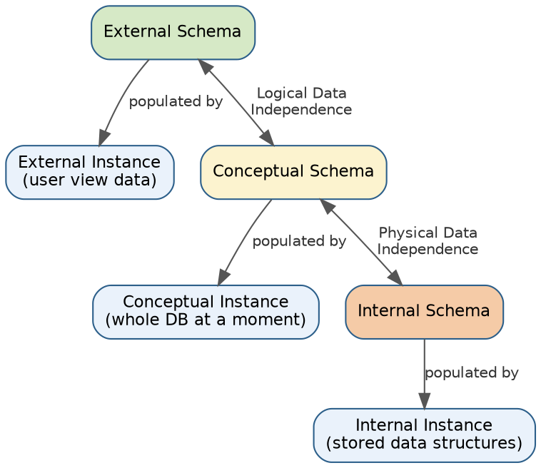
• Each of the three schema levels (External, Conceptual, Internal) has its own corresponding Instance — the actual data as seen or stored at that level at a given moment.
• The External Schema is populated by the External Instance, representing the data visible in a specific user view.
• The Conceptual Schema is populated by the Conceptual Instance, representing the entire database's data at a moment in time.
• The Internal Schema is populated by the Internal Instance, representing the data as physically stored (files, indexes, etc.).
• Logical Data Independence allows the Conceptual Schema to change without affecting External Schemas, so user views and instances remain unaffected.
• Physical Data Independence allows the Internal Schema to change without affecting the Conceptual Schema, so the logical structure and its instance remain unaffected even if physical storage changes.
Answer 10: Concept Map — Roles and Responsibilities in a DBMS Environment
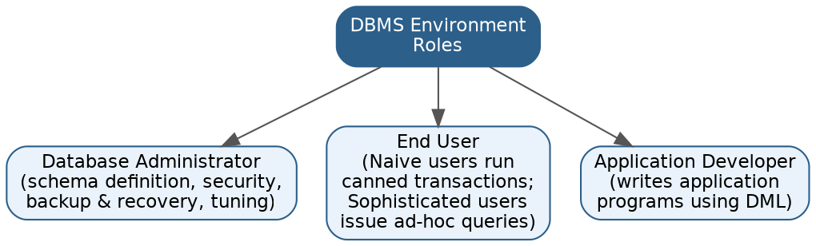

• Database Administrator (DBA): responsible for overall control of the database — defining the schema, granting authorization/access, ensuring security, performing backup and recovery, and monitoring performance/tuning.
• End User: interacts with the database through the applications or query interfaces. Naive users run predefined, canned transactions (e.g., a bank teller checking a balance), while Sophisticated users interact directly by writing ad-hoc queries (e.g., analysts, business users using SQL).
• Application Developer: writes application programs that use Data Manipulation Language (DML) calls to interact with the database on behalf of end users, without needing to know low-level storage details.
• Together, these three roles ensure the database is properly administered, correctly used, and effectively accessed through well-built applications.

